


Patient Information Sheet

What is Beating the Blues

Beating the Blues is an online treatment programme that uses cognitive behavioural therapy (CBT) to help people experiencing depression and/or anxiety.

What is CBT

CBT is a psychological therapy that works on the relationships between thoughts (cognitions), behaviours and feelings. CBT teaches the individual how to recognise and tackle problems here and now, rather than in the past. It has been widely studied and has been proven to work especially on depression and anxiety.

What does Beating the Blues consist of

Beating the Blues consists of eight, one hour sessions completed weekly. The programme is interactive, during session you can watch video clips, complete exercises and learn CBT techniques that can help with depression and anxiety. Each week you will be given tasks to complete during the week between sessions.

How will it help me

Beating the Blues will help you to pinpoint and change unhelpful ways of thinking that can affect how you feel while teaching you more effective ways of solving problems.

How many sessions do I need to complete

It is important to complete as may sessions as possible. When completing the first couple of sessions it may be hard to see how it is relevant to your situation however the programme is designed to build up your knowledge and skills over the weeks, if you stop too early you will not get the full benefits of the treatment.

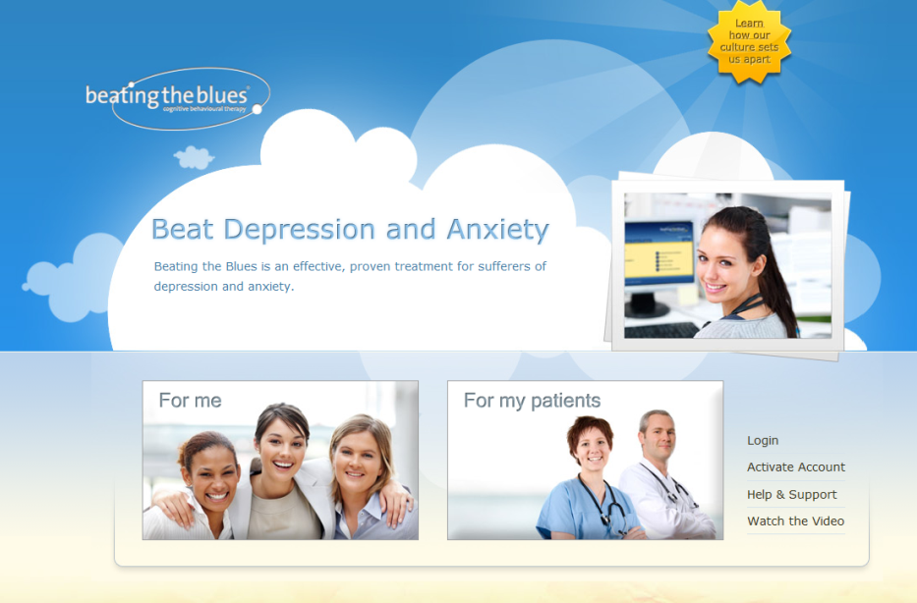
How do I access BtB

To access the programme you will need an activation code which you will get from your local Beating the Blues co-ordinator.

When you have this go to: http://www.beatingtheblues.co.uk, scroll to the bottom of the screen and click on the "Activate Account" link found on the right-hand side. Enter your activation code and follow on screen instructions.

Where can I complete the course

The course can be completed in your home or in a community site such as a library. To do it at home you need a PC, laptop or tablet with either speakers or earphones and access to a printer. When doing it at home it is important to set a side about 1 hour to complete your session at roughly the same time each week. You can also start at home or at one of our sites and change if for example you want a bit more support or have problems getting time off work to attend a site during the day. Talk to your Beating the Blues administrator to discuss these options at any time during the course.

Is the information I put in confidential

Yes. You have a username and password so that no-one else can access the details you enter and all your data is stored in an encrypted database. On a weekly basis however the programme will generate a progress report that contains a limited amount of information relating to how you have felt since your last session. This report will be reviewed by your Beating the Blues administrator and may be shared with your referrer. The information in this report is used to ensure your safety and to monitor your progress throughout the treatment.

Sometimes data that is routinely collected during the course of the treatment will be used in service improvement and evaluation. The information maybe shared with other Health Boards, nationally with NHS 24 or with the EU. This information is always anonymised, this means all information that could be used to identify you is removed and your confidentiality is maintained.

What happens if I say yes to suicidal thoughts

Each week the programme will ask you if you have had suicidal thoughts. If you answer yes your Beating the Blues co-ordinator will inform the person that referred you to the programme. If you are completing the course outside of standard working hours it is recommended you contact NHS 24 to discuss these feelings. The Beating the Blues co-ordinator will then inform your referrer in the morning of the next working day.

What happens if I phone NHS 24

NHS 24 has highly trained staff available 24 hours a day. When you call they will ask you a series of questions which will help them determine the best way to support and help you. This may include transferring you a clinical nursing staff, the Samaritans or Breathing Space.

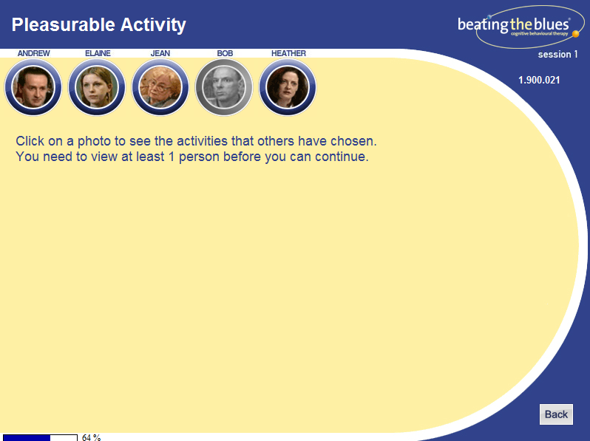
What does it looks like

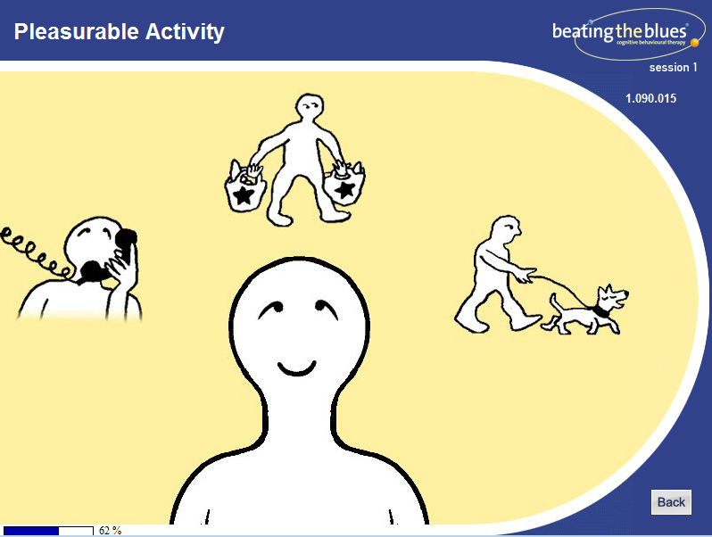

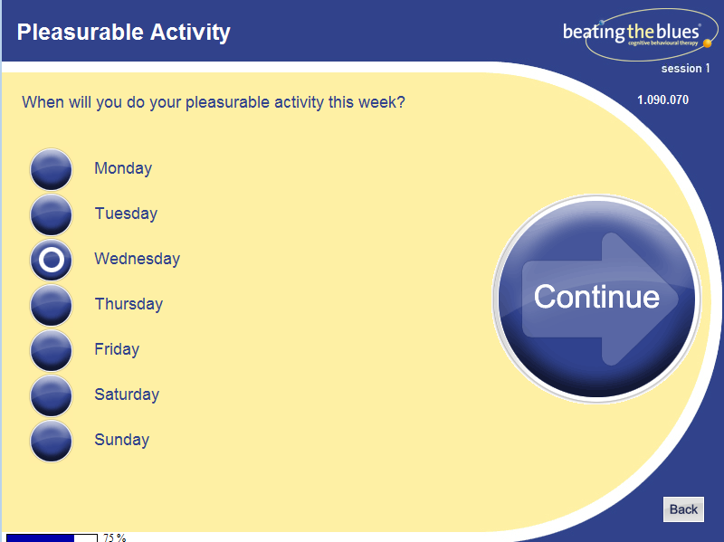

The Sessions

Session 1: Getting Started

- Helps you to establish a clear picture of your problems and their causes.
- Video clips are shown of people with similar problems to your own.
- Teaches some useful ways of dealing with anxiety and depression.

Session 2: Goal Setting & Automatic Thoughts

- Helps you to set your goals for therapy.
- Shows the links between your feelings and what you do, think and say.
- Helps you to tap into your thoughts and the effect they have on you.
- Offers you a choice of two new ways to help you deal with your individual problems.

Session 3: Common Thinking Distortions in Anxiety & Depression

- Shows how our thinking often becomes twisted when we are stressed, anxious or depressed, which makes us even more upset.
- We describe this pattern as a ‘thinking error’.
- This session teaches you how to check your thoughts for such ‘thinking errors’.

Session 4: Changing Unhelpful Thinking

- Teaches you how to change any unhelpful thoughts you may have.
- Introduces another technique for dealing with your particular problems.

Session 5: Inner Beliefs

- Helps you to find out more about your beliefs to check whether they are helpful or not.
- Teaches you how to change unhelpful beliefs in order to feel better and stay better.

Session 6: Inner Beliefs (continued) and Attributional Style

- Looks at the reasons we give for events in our lives. Some types of reasons lead to feelings of low self-esteem and hopelessness.

Session 7: Attributional Style (continued)

- Continues the work you started in the last session on ‘reasons’.
- Each of us has learned a particular way of explaining things and this session helps you to check your particular way.
- You will learn new thinking habits and further ways to deal with our particular problem.

Session 8: Conclusion and Coping with Setbacks

- In this last session, you review all that you have learnt in the programme and check your progress on dealing with your problems.
- Helps you to set goals for the coming months
- Helps you to plan what to do in case you face a setback in the future.

